complete the following tasks:
Review the chapter questions for Chapters 10, 11, 13, and 14, which are designed to help you practice and assess your understanding of the concepts presented in the chapter.
- Complete the following assigned chapter questions:
  - Chapter 10: Questions 2, 3, and 5
  - Chapter 11: Questions 3 and 6
  - Chapter 13: Questions 3 and 5
  - Please give a explanation as to how you solved any mathematical problems

chapter 10
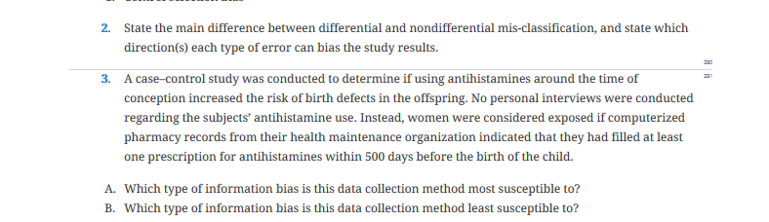
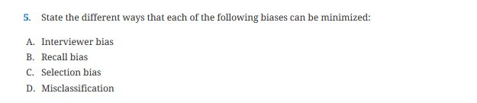
chapter 11
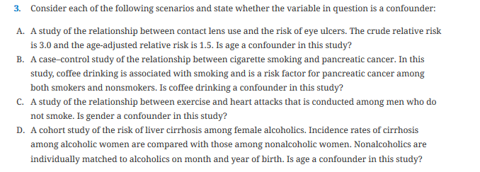
chapter 13
